Science Reviewer
Chemical Reactions
Chemical Changes and Reactions:
- Chemical Changes (Reactions) – Involve the transformation of substances into new ones, often accompanied by observable clues like color change, gas production, or temperature change. (e.g. burning wood into ash and gas)
$$S+H2​+Na→NaHS$$
- Physical Change – Does not alter the chemical composition of substances; they only change their appearance or state. (e.g. melting ice into water)

Indicators of Chemical Reactions:
- Color Change – A change in color often indicates a chemical reaction. Example: Iron changes from shiny silver to reddish-brown rust.
- Formation of Precipitate – A precipitate is a solid or cloudy material that forms in a solution. Example: Mixing vinegar and milk produces curds (lumps).
- Gas Production – The release of gas or bubbles is a sign of a chemical reaction. Example: Baking soda and vinegar produce carbon dioxide (CO₂) gas.
- Temperature Change – Chemical reactions may release heat (exothermic) or absorb heat (endothermic). Example: Burning wood releases heat.
- Light Emission – Some chemical reactions produce light. Example: Fireworks emit colorful light when ignited.
- Odor Change – A change in smell can indicate a chemical reaction. Example: Freshly baked bread and roasted coffee beans develop distinctive aromas.
- Change in Taste – A chemical reaction may cause a change in taste. Example: Caramelization of sugar during cooking.
- Formation of New Substances – A chemical reaction forms new substances with different properties. Example: Hydrogen and oxygen combine to form water (H₂O).
- Release or Absorption of Energy – Chemical reactions either release energy (exothermic) or absorb energy (endothermic). Example: Combustion releases heat and light, while dissolving ammonium nitrate in water absorbs heat.

Endothermic and Exothermic Reactions:
- Endothermic Reaction – Occurs when the temperature of the surroundings decreases. Endothermic reactions are chemical reactions that absorb heat or energy from their surroundings for the reaction to proceed.
- Heat Absorption – Energy is taken from the surroundings in the form of heat. This means that the reactants have a lower energy level than the products.
- Temperature Decrease – The temperature of the surrounding environment drops as head is absorbed. For example, you might feel a sense of cooling I you touch the reaction container.
- Exothermic Reaction – Results in an increase in the temperature of the surroundings. This chemical reaction that releases heat or energy into their surroundings as they proceed.
- Heat Release – Exothermic reactions release energy in the form of heat. This results to reactants having a higher energy than the products.
- Temperature Increase – The temperature of the surrounding environment rises once heat is released. This can be observed when you feel warmth if you touch the reaction container.

Exothermic Reactions | Endothermic Reactions
burning of sugar | melting solid salts
snow formation in clouds | evaporation of water
rusting of iron | cooking an egg
nuclear fission | photosynthesis
reaction of water and a strong acid | baking bread
lighting a candle | mixing water and ammonium nitrate
lighting a firework | splitting a gas molecule
combustion of fuel | electrolysis process

Chemical Reactions that Happen in the Environment:
- Photosynthesis – A chemical reaction that converts carbon dioxide (CO₂) and water (H₂O) into glucose and oxygen (O₂) using sunlight. It occurs in plants, algae, and some bacteria, providing food (energy) for plants and releasing oxygen into the atmosphere.
- Respiration – A chemical reaction in plants, animals, and microorganisms that breaks down glucose using oxygen to produce carbon dioxide (CO₂), water (H₂O), and energy. It helps maintain the oxygen–carbon dioxide balance in the atmosphere.
- Combustion Reactions – A rapid reaction between a fuel and oxygen that produces heat, carbon dioxide (CO₂), water vapor, and pollutants. It is responsible for energy production in vehicles, power plants, and wildfires.
- Ozone Depletion – Chlorofluorocarbons (CFCs) and other ozone-depleting substances react with and break down ozone (O₃) in the ozone layer, allowing more ultraviolet (UV) radiation to reach Earth and increasing risks to human health and ecosystems.
- Biogeochemical Cycles – Chemical reactions involved in the carbon, nitrogen, and phosphorus cycles. These reactions transform elements and compounds, such as converting atmospheric nitrogen (N₂) into ammonia (NH₃) through nitrogen fixation.

Acids, Bases, and Salts
Acids:
- Acids – Chemical substances that when dissolved in water or in an aqueous solution, release hydrogen ions $(H^{+})$ or protons. One of their characteristics is their ability to increase the concentration of hydrogen ions in a solution, which leads to a decrease in the pH of that solution. The increase in hydrogen ions gives acids their distinctive properties, including their sour taste, ability to turn blue litmus paper red, and their corrosive or reactive nature when they come into contract with certain materials.
- Strong Acids – Completely ionize in water and release a high concentration of hydrogen ions.
- Weak Acids – Only partially ionize and release fewer hydrogen ions.

Property | Description
Taste | Acids often have a sour or tart taste.
Texture | Concentrated acids can be corrosive and have a slippery or oily feel.
pH Level | Acids have a pH below 7 on the pH scale. The lower the pH, the stronger the acid.
Conductivity | Many acids conduct electricity when dissolved in water due to the presence of free hydrogen ions (H⁺ ions).
Reactivity | Acids react with metals to produce hydrogen gas and with carbonates to release carbon dioxide gas.
Indicator | They have the ability to neutralize bases. Turn blue litmus paper to red.

Strong Acids | Weak Acids
Hydrochloric acid (HCl) | Acetic acid (CH₃COOH)
Sulfuric acid (H₂SO₄) | Citric acid (C₆H₈O₇)
Nitric acid (HNO₃) | Carbonic acid (H₂CO₃)
Hydrobromic acid (HBr) | Phosphoric acid (H₃PO₄)
Perchloric acid (HClO₄) | Formic acid (HCOOH)

Bases:
- Bases – Chemical substances that, when dissolved in water or in an aqueous solution, release hydroxide ions or other negatively charged ions that can accept hydrogen ions. They are characterized by their ability to increase the pH of that solution. An increase in hydroxide ions gives bases their distinctive properties, including their bitter taste ability to turn red litmus paper to blue, and their slippery or soapy feel when in concentrated form.
- Strong Bases – Completely dissociate in water, releasing a high concentration of hydroxide ions.
- Weak Bases – Partially dissociate and release fewer hydroxide ions.
Property: | Description:
Taste | They often have a bitter taste.
Texture | Generally slippery or soapy to the touch.
pH Level | Have a pH above 7 on the pH scale. The higher the pH, the stronger the base.
Conductivity | Conduct electricity when dissolved in water due to the presence of free hydroxide ions (OH⁻ ions).
Reactivity | Can react with fats and oils in a process called saponification.

Strong Bases: | Weak Bases:
Sodium hydroxide (NaOH) | Ammonia (NH₃)
Potassium hydroxide (KOH) | Methylamine (CH₃NH₂)
Barium hydroxide (Ba(OH)₂) | Aniline (C₆H₅NH₂)
Salt:
- Salt – Chemical compounds formed when acids react with a base in a chemical reaction known as neutralization. They are typically composed of positively charged ions (cations) and negatively charged ions (anions) held together during ionic bonding. These positive and negative charges of the ions balance each other, resulting in a neutral compound.
  - Sodium Chloride (NaCl or Table Salt) – Most common type of salt composed of hydrochloric acid (HCl) and react is with a base like sodium hydroxide (NaOH) that have the ability to neutralize each other forming salt (NaCl) and water (H₂O).
Name and Chemical Formula | Common Name | Uses
Sodium chloride (NaCl) | Table salt | Food preparation, making of chemicals
Potassium chloride (KCl) | Potassium chloride | Used as a salt substitute and in medical applications
Magnesium sulfate (MgSO₄) | Epsom salt | Used in baths and as a laxative
Calcium carbonate (CaCO₃) | Calcite, chalk | Found in limestone, marble, and antacids
Sodium bicarbonate (NaHCO₃) | Baking soda | Used in cooking and as an antacid
- Saline Solution – Mixture of salt (NaCl) dissolved in water and usually have a neutral pH value of around 7. It is commonly used in medical and scientific solutions used for various purposes due to its compatibility with biological systems and cells.
- They typically contain a specific concentration of salt dissolved in purified water. They have various medical applications such as intravenous fluids, would cleaning, contact lens care, and eye drops which can be used to maintain a stable pH environment in medical applications.

Potential of Hydrogen (pH Level): Understanding Alkalinity and Acidity
- Potential of Hydrogen (pH Level) – Important concept in representing the measure of the acidity or alkalinity of a solution and measures the concentration of hydrogen ions in a solution. The pH scale ranges from 0-14. The scale of works logarithmically, pH of 4 is ten times more acidic than a solution with pH level of 5.
pH Value | Classification | Description
0–3 | Strong Acid | Very acidic; high concentration of H⁺ ions
4–6 | Weak Acid | Mildly acidic
7 | Neutral | Equal concentration of H⁺ and OH⁻ ions
8–10 | Weak Base | Mildly basic (alkaline)
11–14 | Strong Base | Very basic; high concentration of OH⁻ ions

Indicators:
- Indicators – Special substances that can help identify an acid, base, or just plain neutral that are used in chemistry to detect the presence or measure the properties of other substances. They play a vital role in various scientific and practical applications. Because these characteristics, they help determine characteristics such as acidity, basicity, or the endpoint of a chemical reaction.
- Acidity – The degree of acidity of a substance, determined by the concentration of hydrogen ions (H⁺). Acids have a pH below 7 and typically donate H⁺ ions in a solution.
- Basicity – The degree of basicity (alkalinity) of a substance, determined by the concentration of hydroxide ions (OH⁻) or its ability to accept H⁺ ions. Bases have a pH above 7.
- Endpoint – The point in a titration where the indicator changes color, signaling that the reaction is complete or nearly complete. It is used to estimate the equivalence point, where the acid and base have reacted in the correct proportions.
- Types of Indicators:
- Litmus Paper – Paper strips treated with natural dyes from lichens that change color based on a solution's pH. Blue litmus turns red in an acid, while red litmus turns blue in a base.
- Universal pH Paper – An indicator paper that measures a solution's acidity or alkalinity using a color scale corresponding to pH values from 1–14, providing a more precise result than litmus paper.
- Phenolphthalein – An acid-base indicator that is colorless in acidic solutions (pH < 7) and turns pink to deep red in basic solutions (pH > 8.2).
- Bromothymol Blue – An indicator that is yellow in acidic solutions, green in neutral solutions, and blue in basic solutions.
- Methyl Orange – An indicator that is red in acidic solutions, yellow in neutral solutions, and orange to red in basic solutions.
- Common Applications of Indicators:
- Acid-Base Titrations – Indicators are used to determine the endpoint of an acid-base titration, showing when the reaction is complete through a color change.
- Environmental Testing – Indicators are used to measure the pH of soil, water bodies, and wastewater to monitor environmental health.
- Medical and Biological Research – pH indicators are used in laboratories to measure the pH of biological samples, such as blood, for diagnosing and monitoring health conditions.
- Quality Control – Indicators help ensure the quality and safety of products, including food and pharmaceuticals, by verifying the correct pH levels.
- Education – Indicators are valuable teaching tools for learning about chemical reactions, pH, acids, bases, and experimental techniques through hands-on activities.

Processes of Chemical Change:
- Oxidation – A chemical reaction in which a substance loses electrons, often by combining with oxygen or losing hydrogen. Oxidation commonly results in the formation of oxides, such as rust, and is involved in processes like corrosion, combustion, and cellular respiration.
- Example: Iron reacts with oxygen to form rust: 4Fe + 3O₂ → 2Fe₂O₃
- Reduction – A chemical reaction in which a substance gains electrons, often by losing oxygen or gaining hydrogen. Reduction always occurs together with oxidation in a process called a redox (reduction-oxidation) reaction.
- Example: Copper (II) oxide is reduced to copper: CuO + H₂ → Cu + H₂O
- Neutralization – A chemical reaction in which an acid reacts with a base to produce water and a salt. This reaction reduces the acidity or basicity of the solution, moving it closer to a neutral pH (7).
- Example: Hydrochloric acid reacts with sodium hydroxide: HCl + NaOH → NaCl + H₂O
- Hydrolysis – A chemical reaction in which water (H₂O) is used to break down a compound into simpler substances. Hydrolysis is important in digestion, food processing, and many biological and industrial reactions.
- Example: Sucrose is broken down into glucose and fructose: C₁₂H₂₂O₁₁ + H₂O → C₆H₁₂O₆ + C₆H₁₂O₆
- Fermentation – A chemical and biological process in which microorganisms such as yeast or bacteria convert sugars into alcohol, organic acids, or gases without the presence of oxygen (anaerobic process). It is widely used in making bread, yogurt, cheese, beer, and wine.
- Example: Yeast converts glucose into ethanol and carbon dioxide: C₆H₁₂O₆ → 2C₂H₅OH + 2CO₂ + Energy

Laws of Chemical Change:
- Law of Conservation of Mass – A fundamental law of chemistry stating that mass cannot be created or destroyed during a chemical reaction. This means the total mass of the reactants is always equal to the total mass of the products, because atoms are only rearranged, not created or destroyed.
- Example: 2H₂ + O₂ → 2H₂O
4 g of H₂ + 32 g of O₂ = 36 g of H₂O
- Law of Definite Composition – A fundamental law of chemistry stating that a pure chemical compound always contains the same elements combined in the same fixed ratio by mass, regardless of its source or how it was prepared.
- Example: Water (H₂O) is always made of 2 hydrogen atoms and 1 oxygen atom, with a mass ratio of about 1:8 (2 g H + 16 g O = 18 g H₂O).
- Law of Multiple Proportions – A fundamental law of chemistry stating that when two elements form more than one compound, the masses of one element that combine with a fixed mass of the other are in simple whole-number ratios.
- Example: Carbon and oxygen form two compounds:
- CO (Carbon Monoxide): 12 g C + 16 g O
- CO₂ (Carbon Dioxide): 12 g C + 32 g O
With 12 g of carbon fixed, the oxygen masses are 16 g and 32 g, giving a 1:2 ratio, which follows the Law of Multiple Proportions.

Chemical Reactions:
- Chemical Reactions – Chemical reactions are processes in which one or more substances, called reactants, are transformed into new substances, called products, through the breaking and forming of chemical bonds. During a chemical reaction, atoms are rearranged, but they are not created or destroyed, in accordance with the law of conservation of mass.
- Descriptions – Chemical reactions involve changes at the molecular or atomic level, where reactants interact through collisions to break and form bonds, producing products with different chemical and physical properties, and energy is released (exothermic) or absorbed (endothermic).
- Exothermic Reactions – Release energy (heat/light/sound), warming surroundings.
- Endothermic Reactions – Absorb energy from surroundings, making them feel cold.
- Characteristics – Formation of new substances with distinct properties, rearrangement of atoms without changing their total number, energy change (heat, light, electricity, or sound may be produced or absorbed), and observable signs like color change, gas formation, precipitate formation, or temperature change.
- Types of Chemical Reactions:
- Combination (Synthesis) Reaction – A combination reaction is a type of chemical reaction where two or more simple substances combine to form a single compound, resulting in one product and is common in the formation of compounds.
- General Equation: A + B = AB
- Decomposition Reaction – A decomposition reaction is a type of chemical reaction where a single compound breaks down into two or more simpler substances, often requiring energy such as heat, light, or electricity, and is the opposite of combination reactions.
General Equation: $AB = A + B$
- Single Displacement (Replacement) Reaction – A single displacement reaction is a type of chemical reaction where one element replaces another element in a compound, occurring when one element is more reactive than the other and is common in metal reactions with acids.
- General Equation: $A + BX = AX + B$
- Double Displacement (Replacement) Reaction – A double displacement reaction is a type of chemical reaction where ions in two compounds exchange partners to form two new compounds, often occurring in aqueous solutions and may form a precipitate, gas, or water.
- General Equation: $AX + BY = AY+ BX$
- Combustion Reaction – A combustion reaction is a type of chemical reaction where a substance reacts rapidly with oxygen, producing energy in the form of heat and light, usually involving hydrocarbons and serving as an important source of energy.
- General Equation: $fuel + O₂ → CO₂ + H₂O + energy$
- Acid-Base (Neutralization) Reaction – An acid-base reaction is a type of chemical reaction where an acid reacts with a base to produce salt and water, involving the transfer of protons (H⁺) and reducing acidity or basicity.
- Redox (Oxidation-Reduction) Reaction – A redox reaction is a type of chemical reaction involving the transfer of electrons between substances oxidation is the loss of electrons and reduction is the gain of electrons, and it occurs in many reaction types such as combustion and displacement reactions.
- Oxidation: loss of electrons
- Reduction: gain of electrons
- Occurs in many reaction types (combustion, displacement)

Writing Chemical Equations:
Symbol: | Type: | Meaning:
$$H₂$$ | Formula | Identity of reactant or product
$$2, 3, etc.$$ | Coefficient | Indicates number of particles
$$→$$ | Yields | Yields or Produces
$$+$$ | Plus | … and …
$$(g)$$ | State | Gas
$$(l)$$ | State | Liquid
$$(s)$$ | State | Solid
$$(aq)$$ | State | Aqueous (dissolved in water)

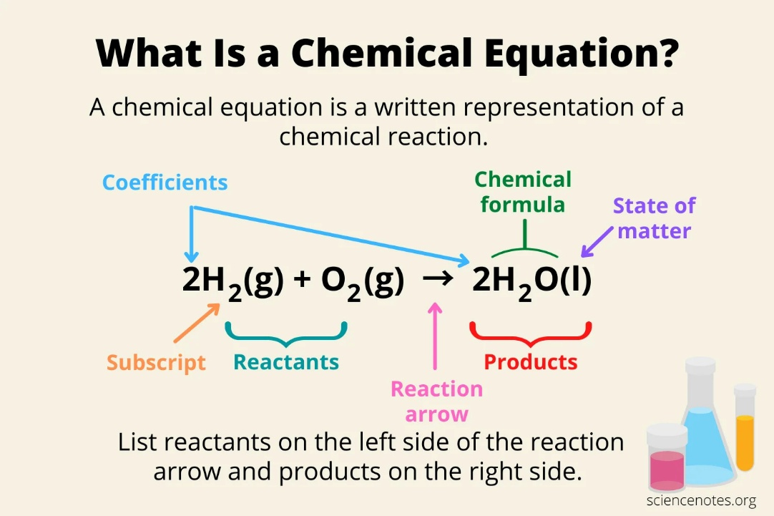
Writing Chemical Equations\
Type | How to recognize it | Formula rule | Examples
Monatomic ions | Ends in -ide (single atom ion) | Write the symbol with its ionic charge | Chloride → Cl⁻  Oxide → O²⁻  Nitride → N³⁻
Polyatomic ions | Usually ends in -ate or -ite (except hydroxide, cyanide, ammonium) | Memorize the whole ion as one unit | Sulfate → SO₄²⁻  Nitrate → NO₃⁻ Carbonate → CO₃²⁻
Diatomic elements | Seven elements that naturally exist as pairs (gases under standard conditions, except bromine liquid and iodine solid) | Always write ₂ when they are by themselves | H₂, N₂, O₂, F₂, Cl₂, Br₂, I₂

Diatonic Ions
Mnemonic Word | Element | Formula
Have | Hydrogen | H₂
No | Nitrogen | N₂
Fear | Fluorine | F₂
Of | Oxygen | O₂
Ice | Iodine | I₂
Cold | Chlorine | Cl₂
Beer | Bromine | Br₂

